Leveraging Machine Learning for COVID-19 Diagnosis

Mansi1, Nandini Vashistha1, Upendra Mishra2

1Department of Computer Science and Engineering, KIET Group of Institutions, Delhi-NCR, Ghaziabad, India

2 Faculty of Department of Computer Science and Engineering, KIET Group of Institutions, Delhi-NCR, Ghaziabad, India

*Author to whom correspondence should be addressed:

E-mail: vashisthanandini@gmail.com

.

**Abstract**: To address the pandemic and cover the major health crisis, innovative diagnostic technologies have been urgently developed and put into use to take over the widespread health crisis. The study deals with the use of advanced artificial intelligence (AI) methods, most particularly machine learning models like ResNet50 and Extreme Learning Machine (ELM), to analyze chest X-rays and CT scans, for example, in connection with the discovery of COVID-19 and the severity of the latter. This technology also indicates that machine learning is revolutionizing the way COVID-19 and its sister diseases are diagnosed. The study makes a case for integrated use of AI improving patient care, resource allocation, and health outcomes via its medical imaging representation.

Keywords—COVID-19, Machine Learning, Artificial Intelligence, Medical Imaging, ResNet50, Extreme Learning Machine

1. Introduction

In December 2019, a cluster of pneumonia cases emerged in Wuhan, China, of initially unknown origin. Very soon afterwards, a novel coronavirus was identified to cause these infections. The organization gave the name severe acute respiratory syndrome coronavirus 2 (SARS-CoV-2) to the virus and referred to the disease it causes as coronavirus disease 2019 (COVID-19). Facebook provides their non-profit pages with an exceptional opportunity to link their great causes and create a variance for present and fund. Generally, disease assessment can primarily fall into three categories: supervised learning, unsupervised learning, and reinforcement learning. Underneath these methodologies are computational approaches such as clustering and dimensionality reduction. Deep Learning techniques, their flexibility and adaptability, have been engaged in complex tasks such as image classification related to medical imaging and Natural Language Processing. As of the time of reporting, Johns Hopkins University estimated that a total of approximately 230 million infections and 4.7 million deaths have occurred worldwide since COVID-19, reinforcing the need for constant research attention. This study attempts to automate diagnosis of COVID-19 with the aid of chest X-ray images and relevant deep learning techniques such as ResNet, PCA, and Extreme Learning Machine (ELM). Advances in deep learning are substantially helping in the detection of COVID-19 through the analysis of chest X-ray images. Multi-class classification model attained an accuracy of 0.935, which implies COVID-19 is detected in patients fast and accurately. One of the most crucial consequences of the COVID-19 pandemic seems to be pneumonia, which is placing a heavy burden on healthcare systems around the world. It is important that pneumonia associated with COVID-19 was diagnosed timely and accurately for successful management and alleviation of the burden on medical facilities. Although computed tomography (CT) is the most accurate method for diagnosing pneumonia, using CXR imaging is still indicated because of rapidity, cost-effectiveness, and availability. In response to this need, a study developed a classification system for different types of pneumonia, employing resampling methods to address class imbalances alongside hierarchical and multi-class classification techniques. Using a pre-trained convolutional neural network (CNN) model, texture features were extracted from CXR images were extracted using both traditional descriptors and a pre-trained CNN model, with early and late fusion techniques to improve performance. The framework was evaluated on the RYDLS-20 database, which includes images of various pneumonia types and healthy lungs, reflecting real-world class distribution.

2. Material and Methods

2.1 Dataset

This study is meant to be a very detailed report on the various machine learning algorithms applicable for creating and evaluating models for COVID-19 detection from medical images. Since the classification of COVID-19 relies heavily on chest X-ray and CT images, the dataset consists of images from this domain and is extremely amenable to analysis

Fig 1. Chest XRay of a Covid Patient 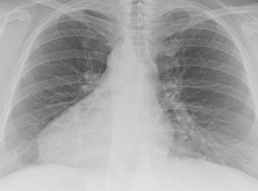

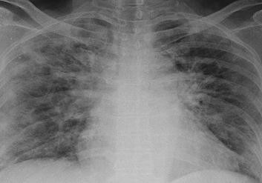

Fig 2. Chest XRay of a Non-Covid Patient

2.2 Data Analysis

Feature Selection and Extraction: Relevant features were chosen using images to enhance precision and reduce computational load which are explained below:

1) Data Preprocessing: The data set consists of X-ray images divided into two classes: Covid-19 and Non-Covid 19.

2) Preparing the image: To satisfy ResNet50 input, images are reduced to (224, 224). Normalization is done with mean and standard deviation values specific to ImageNet (the pretrained model is recomputed on the same values).

3) Transformation Pipeline: The extracted features of each image are numerical vectors in a high-dimensional space and detail important information learned by the model.

4) Normalization: StandardScaler is used to scale the features to have a mean of 0 and standard deviation of 1, which is then provided as input in the machine learning models. This accelerates convergence of the model while training.

3. Proposed Methodology

The X-ray image data was thoroughly preprocessed to assure high-quality inputs for Covid diagnosis, with an emphasis on the diseased portion of the lungs. After preprocessing, two ensemble models were created: one based on CNN and the other including a hybrid ELM mechanism, both of which were aimed to optimize prediction performance. A detailed discussion of the model architectures follows, where the preprocessed data is utilized by the networks, and the outputs are strategically combined in the ensemble to refine diagnostic precision. The models are extensively developed for created an enhanced ensemble learning model for achieving higher accuracy and precision in diagnosing the disease. The block diagram shows the presented methods and their further steps like model tuning, evaluation, and output in developing the model.

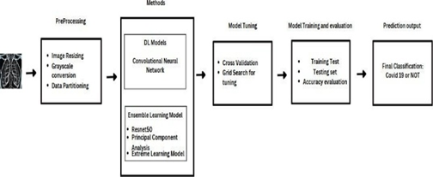

Fig. 3. The block diagram of presented methods.

**3.1 Resnet50**

The ResNet50 framework forms the chief foundation for the fundamental feature extraction technique, wherein its deep residual learning concept works in a supportive fashion to deal with the vanishing gradient problem and assist in training deeper networks. Transfer learning uses the ImageNet dataset to initialize ResNet50 through previously obtained weights, and, through doing this, the model will build upon previous knowledge about a wide range of images.

In this stage, the first few layers of the ResNet50 architecture are frozen, and in train, only the fully connected layers on the COVID-19 dataset; thus, those involved in training allow adaptation of patterns specific to that model without interfering with the learned feature representations.

Subsequently, more layers are gradually unfrozen and tuned to fine-tune the model with a low learning rate for enhanced feature extraction to boost performance on the COVID-19 dataset.

**3.2 Proposed Hybrid Model of CNN with ELM**

**3.2.1 Resnet50**: The ResNet50 framework forms the chief foundation for the fundamental feature extraction technique, wherein its deep residual learning concept works in a supportive fashion to deal with the vanishing gradient problem and assist in training deeper networks. Transfer learning uses the ImageNet dataset to initialize ResNet50 through previously obtained weights, and, through doing this, the model will build upon previous knowledge about a wide range of images. In this stage, the first few layers of the ResNet50 architecture are frozen, and in train, only the fully connected layers on the COVID-19 dataset; thus, those involved in training allow adaptation of patterns specific to that model without interfering with the learned feature representations. Subsequently, more layers are gradually unfrozen and tuned to fine-tune the model with a low learning rate for enhanced feature extraction to boost performance on the COVID-19 dataset

**3.2.2 PCA:** PCA is one of the most widely employed statistical methodologies for dimensionality reduction of the high-dimensional data into fewer dimensions so that maximum variance is kept. It is helpful for many machine learning and data analysis tasks, since high dimensional datasets usually lead to problems like overfitting, increased computational cost, and imbalance in visualization. In PCA, the first step is the standardization of the dataset by centering to zero- which entails subtracting each feature's mean from every data point.

Z=σX−μ

The eigenvalues and eigenvectors of the covariance matrix are then determined using the eigenvalue decomposition.

cov(x1,x2)=AX=λX

AX−λX(A−λI)=0=0

∣A–λI∣=0

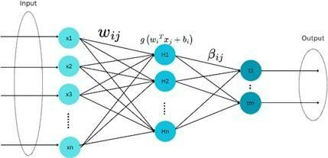**3.2.3 Extreme Machine Learning (ELM):** The Extreme Learning Machine (ELM) classifier is a machine learning model that uses a single- layer feedforward neural network architecture. This architecture is a popular choice for a variety of classification problems due to its excellent generalization capabilities and quick training times. Unlike traditional neural networks, which require repeated training to change weights, ELMs train only the output layer and assign weights to the hidden layer at random.

Fig 4. Schematic Diagram of ELM Model

The mathematical foundation of ELM can be explained as follows:

**Forward Pass Equation:** The relationship between input X, hidden layer output H and target output Y is as follows:

H.β = Y

Where X 𝜖 ℝ{𝑛×𝑑} is Input data with n samples and d features, H 𝜖 ℝ{𝑛×𝑚} Hidden layer output matrix with m hidden nodes, β 𝜖 ℝ{𝑚×𝑘} output weights between the output and hidden layers, Y 𝜖 ℝ{𝑛×𝑘} Target output matrix.

**Hidden Layer Output:** The activation function is used to calculate the hidden layer output H. g(⋅).

ℎ{𝑖𝑗} = 𝑔(𝑤𝑗 ⋅ 𝑥𝑖 + 𝑏𝑗)

Where ℎ𝑖𝑗 is the output of the j-th hidden node for the i-th input, g(.) is the activation function, 𝑦𝑗 is the j-th hidden node's weights, 𝑥𝑖 is the i-th input sample, and 𝑏𝑗 is its bias.

**Optimization of Output Weights (β):** Using the Moore-Penrose pseudoinverse, the optimal β is calculated as:

𝛽 = 𝐻∗Y

Where 𝐻∗ = (𝐻𝑇𝐻)−1𝐻𝑇 if (𝐻𝑇𝐻) 𝑖𝑠 𝑖𝑛𝑣𝑒𝑟𝑡𝑖𝑏𝑙𝑒

**Regularized Optimization:** To handle ill-conditioned problems, a regularization term is added:

Β= (𝐻𝑇𝐻 + 𝜆𝐼)−1 𝐻𝑇𝑌, where I is the identity matrix and λ is the regularization parameter.

**Classification Decision:** For classification, the predicted output Ŷ is:

Ŷ=H.β

The class label is determined using:

ŷ𝑖=𝑎𝑟𝑔 𝑚𝑎𝑥𝑘 ŷ𝑖𝑘

Table 1. Layer Architecture of Hybrid Model

|  |  |  |
| --- | --- | --- |
| Layer | Description | Properties |
| Data Preprocessing | Load and normalize dataset images, resize to (224x224) | Resize, Normalize Labels: Binary |
| Feature Extraction | Extract 2048-dimensional features | ResNet50 , Feature size: 2048 |
| Feature Conversion | Flatten features and organize them into labels. | Covid-19 (1), Non Covid-19(0) Output: CSV |
| Dimensionality Reduction | Apply PCA to reduce features to 10 components. | Scaled with StandardScaler |
| Classification (ELM) | Train and evaluate ELM classifier with optimized hyperparameters. | Params: n_hidden (50–200) |

4. Experiment, Results and Analysis

PyTorch and TensorFlow with GPU support were used to accelerate training. Performance was evaluated using metrics such as precision, MSE, Sensitivity, ROCcurve, etc with strict validation and testing procedures. The dataset was divided into training, validation, and testing subsets. The training set optimized model parameters, the validation set mitigated overfitting, and the testing set assessed generalization. This approach allowed for efficient optimization and fine tuning, providing a comprehensive evaluation of the model’s performance against ground truth annotations.

**4.1 Accuracy**

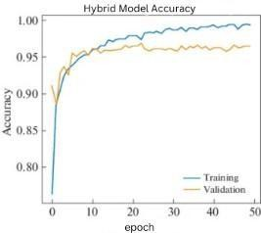Accuracy is defined as the number of instances potentially recovered as true positives and true negatives based upon the total data set. Generally, a measure of the performance of the model across all number of classes. The analysis of the hybrid extreme Machine Learning algorithm showed accuracy of 92% whereas the accuracy in CNN model showed 80%.

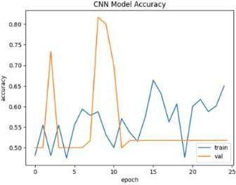Fig 5. CNN Model and Hybrid ELM model Accuracy

Table 2. Accuracy and Validation Accuracy over Epochs

|  |  |  |  |  |
| --- | --- | --- | --- | --- |
| Epochs | CNN Model | | Hybrid ELM Model | |
| Accuracy | Validation Accuracy | Accuracy | Validation Accuracy |
| 0 | 0.4694 | 0.5000 | 0.7568 | 0.9145 |
| 10 | 0.5302 | 0.5000 | 0.9524 | 0.9564 |
| 15 | 0.6049 | 0.5000 | 0.9603 | 0.9510 |
| 25 | 0.6420 | 0.5000 | 0.9613 | 0.9541 |

**4.2 Loss**

During training, loss functions measure the discrepancy between expected and actual results; lower values indicate greater performance. The Hybrid ELM model showed less loss percentage than the CNN model.

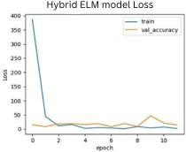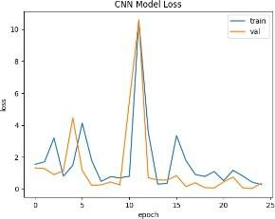

Fig 6. CNN and Hybrid ELM model Loss graph

Table 3. Loss and Validation Loss over Epochs

|  |  |  |  |  |
| --- | --- | --- | --- | --- |
| Epochs | CNN Model | | Hybrid ELM Model | |
| Loss | Validation Loss | Loss | Validation Loss |
| 0 | 2.7406 | 1.4955 | 0.1078 | 380 |
| 10 | 1.0681 | 1.0588 | 0.2514 | 0.1412 |
| 25 | 0.9886 | 0.9525 | 0.3564 | 0.1584 |

**4.3 Precision**

Precision is calculated as the number of true positive results divided by the total number of instances classified as positive, i.e., true positives plus false positives. Essentially, this metric basically tells how reliable is the positive label predicted by a model. More a model is precise, more its probability of a positive prediction is correct. For example, if a certain model indicates positivity, it is most likely correct. In other applications such as medical tests, it is crucial since a false positive wrongly puts patients at a risk of either a needless procedure or anxiety. The hybrid ELM model confirmed a precision rating of 94% in regard to the analysis.

**4.4 F1 Score**

With respect to an imbalanced dataset, the F1 Score is the measure of precision and recall, offering a balanced combination of those metrics. The metric is useful in situations where false positives and false negatives carry different costs. Hence, combining the two in a single quantity, the F1 Score proves to be very useful for comparing the performance of different models. The obtained F1 Score was 93.5%.

**4.5 Specificity**

Sensitivity and Specificity: Specificity measures the ability to detect negatives, whereas sensitivity (also known to be the true positive rate) measures the percentage of positives correctly identified. The Hybrid ELM model correctly identified both cases, with sensitivity and specificity values of 0.85 and 0.95, respectively.

Table 4. Sensitivity and Specificity for Hybrid ELM model

|  |  |  |  |  |
| --- | --- | --- | --- | --- |
| Epochs | Sensitivity | Validation  Sensitivity | Specificity | Validation  Specificity |
|  |  |  |  |  |
| 20 | 0.8217 | 0.9167 | 0.8530 | 0.9116 |
| 40 | 1.0000 | 1.0000 | 1.0000 | 1.0000 |
| 52 | 0.9997 | 1.0000 | 1.0000 | 1.0000 |

**4.6 ROC Curve**

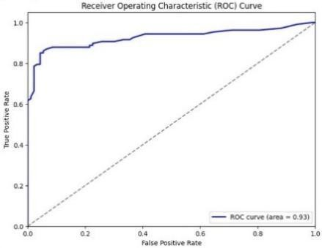The ROC curve is used to evaluate binary classification models by displaying true positive rates against false positive rates. The hybrid model has achieved an AUC of 0.93.

Figure 7. ROC Curve of Hybrid ELM

5. Conclusion

The elevated values of F1 Score, Recall, Accuracy and Precision highlight the proposed method's potency and competence. These results not only demonstrate the method's proficiency in medical image segmentation but also its applicability to classifying chest X-rays, which is crucial for COVID-19 diagnosis. With all performance metrics remaining high, the model comes across as a dependable decision-support tool in a clinical setup. The developed model attains an accuracy of 96%, in line with the diagnostics of radiologists and other healthcare professionals. The ability for rapid and correct assessment by this model could boost the outcomes for patients.

References

1. Aggarwal, S., Gupta, S., Alhudhaif, A., Koundal, D., Gupta, R., & Polat, K. (2022). Automated COVID‐19 detection in chest X‐ray images using fine‐tuned deep learning architectures. Expert Systems, 39(3), e12749.
2. Asif, S., Wenhui, Y., Amjad, K., Jin, H., Tao, Y., & Jinhai, S. (2023). Detection of COVID‐19 from chest X‐ray images: Boosting the performance with convolutional neural network and transfer learning. Expert Systems, 40(1), e13099.
3. Cao, D. M., Amin, M. S., Islam, M. T., Ahmad, S., Haque, M. S., Sayed, M. A., ... & Nobe, N. (2023). Deep Learning-Based COVID-19 Detection from Chest X-ray Images: A Comparative Study. Journal of Computer Science and Technology Studies, 5(4), 132-141.
4. Chowdhury, N. K., Rahman, M. M., & Kabir, M. A. (2020). PDCOVIDNet: A parallel-dilated convolutional neural network architecture for detecting COVID-19 from chest X-ray images. Health Information Science and Systems, 8(1), 27.
5. Constantinou, M., Exarchos, T., Vrahatis, A. G., & Vlamos, P. (2023). COVID-19 classification on chest X-ray images using deep learning methods. International Journal of Environmental Research and Public Health, 20(3), 2035.
6. El Houby, E. M. (2024). COVID-19 detection from chest X-ray images using transfer learning. Scientific Reports, 14(1), 11639.
7. Ghafouri-Fard, S., Mohammad-Rahimi, H., Motie, P., Minabi, M. A., Taheri, M., & Nateghinia, S. (2021). Application of machine learning in the prediction of COVID-19 daily new cases: A scoping review. Heliyon, 7(10).
8. Haghanifar, A., Majdabadi, M. M., Choi, Y., Deivalakshmi, S., & Ko, S. (2022). Covid-cxnet: Detecting covid-19 in frontal chest x-ray images using deep learning. Multimedia Tools and Applications, 81(21), 30615-30645.
9. Huang, C. J., Chen, Y. H., Ma, Y., & Kuo, P. H. (2020). Multiple-input deep convolutional neural network model for covid-19 forecasting in China. MedRxiv, 2020-03.
10. Huang, Z., Pan, Z., & Lei, B. (2017). Transfer learning with deep convolutional neural network for SAR target classification with limited labeled data. Remote Sensing, 9(9), 907.
11. Kwekha-Rashid, A. S., Abduljabbar, H. N., & Alhayani, B. (2023). Coronavirus disease (COVID-19) cases analysis using machine-learning applications. Applied Nanoscience, 13(3), 2013-2025.
12. Lalmuanawma, S., Hussain, J., & Chhakchhuak, L. (2020). Applications of machine learning and artificial intelligence for COVID-19 (SARS-CoV-2) pandemic: A review. Chaos, Solitons & Fractals, 139, 110059.
13. Li, Y., & Xia, L. (2020). Coronavirus disease 2019 (COVID-19): Role of chest CT in diagnosis and management. American Journal of Roentgenology, 214(6), 1280-1286.
14. Mahajan, S., Raina, A., Gao, X. Z., & Pandit, A. K. (2022). COVID‐19 detection using hybrid deep learning model in chest X‐rays images. Concurrency and Computation: Practice and Experience, 34(5), e6747.
15. Mathesul, S., Swain, D., Satapathy, S. K., Rambhad, A., Acharya, B., Gerogiannis, V. C., & Kanavos, A. (2023). COVID-19 detection from chest X-ray images based on deep learning techniques. Algorithms, 16(10), 494.
16. Murugan, R., & Goel, T. (2021). E-DiCoNet: Extreme learning machine-based classifier for diagnosis of COVID-19 using deep convolutional network. Journal of Ambient Intelligence and Humanized Computing, 12(9), 8887-8898.
17. Narin, A., Kaya, C., & Pamuk, Z. (2021). Automatic detection of coronavirus disease (COVID-19) using X-ray images and deep convolutional neural networks. Pattern Analysis and Applications, 24, 1207-1220.
18. Nayak, S. R., Nayak, D. R., Sinha, U., Arora, V., & Pachori, R. B. (2022). An efficient deep learning method for detection of COVID-19 infection using chest X-ray images. Diagnostics, 13(1), 131.
19. Nobi, A., Tuhin, K. H., & Lee, J. W. (2021). Application of principal component analysis on temporal evolution of COVID-19. PLOS One, 16(12), e0260899.
20. Pereira, R. M., Bertolini, D., Teixeira, L. O., Silla Jr, C. N., & Costa, Y. M. (2020). COVID-19 identification in chest X-ray images on flat and hierarchical classification scenarios. Computer Methods and Programs in Biomedicine, 194, 105532.
21. Rajagopal, R. (2021). Comparative analysis of COVID-19 X-ray images classification using convolutional neural network, transfer learning, and machine learning classifiers using deep features. Pattern Recognition and Image Analysis, 31(2), 313-322.
22. Rajpal, S., Agarwal, M., Rajpal, A., Lakhyani, N., Saggar, A., & Kumar, N. (2022). Cov-elm classifier: An extreme learning machine-based identification of COVID-19 using chest X-ray images. Intelligent Decision Technologies, 16(1), 193-203.
23. Rajpal, S., Lakhyani, N., Singh, A. K., Kohli, R., & Kumar, N. (2021). Using handpicked features in conjunction with ResNet-50 for improved detection of COVID-19 from chest X-ray images. Chaos, Solitons & Fractals, 145, 110749.
24. Rohini, M., Naveena, K. R., Jothipriya, G., Kameshwaran, S., & Jagadeeswari, M. (2021, March). A comparative approach to predict coronavirus using machine learning. In 2021 International Conference on Artificial Intelligence and Smart Systems (ICAIS) (pp. 331-337). IEEE.
25. Upadhyay, K., Agrawal, M., & Deepak, D. (2020). Ensemble learning‐based COVID‐19 detection by feature boosting in chest X‐ray images. IET Image Processing, 14(16), 4059-4066.